Robot v1.23

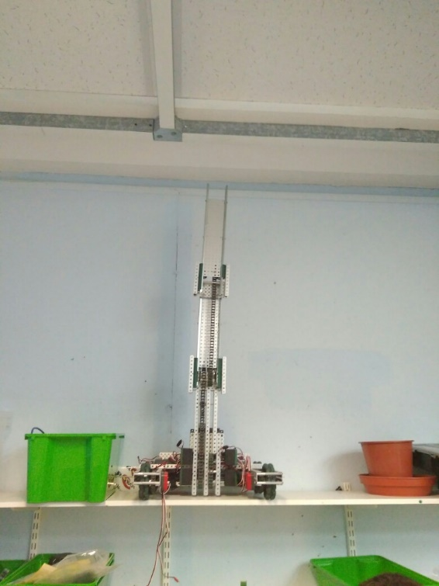

**Specification:**

* 6 Motor HS drive
* 2 drive chains
* 4 wheels
* Aluminium structure
* 4 motor lift
* 3 stage lift
* 2 motor claw

**Dimensions:**

* 17.5” x 15” x 17.5” when not extended

Logged by Robbie Buxton

17/07/2017 – 16:30

**Overview:**

The parts we needed to make the third stage finally arrived (two 12 tooth sprockets) today so we could complete the third stage of lift. The linear action works very well however it a bit lop-sided which is something we will need to fix. After we mount the claw the core robot will be finished and we will be able to focus on fine tuning the robot.

**Future Changes:**

* Plug in shaft encoders
* Make lift straight
* Mount claw

**Changes Made:**

* Added third stage